Claude Certification — Building with the Claude API
Section 7 — Features of Claude
Contents
- Lesson 1 — Extended Thinking
- Lesson 2 — Image Support
- Lesson 3 — PDF Support
- Lesson 4 — Citations
- Lesson 5 — Prompt Caching
- Lesson 6 — Rules of Prompt Caching
- Lesson 7 — Prompt Caching in Action
- Lesson 8 — Code Execution and Files API

Lesson 1 — Extended Thinking

Core idea
Extended thinking is Claude's advanced reasoning feature: it gives the model time to work through a complex problem before writing the final answer. Think of it as Claude's “scratch paper” — you can see the reasoning process that leads to the answer, which helps with transparency and often improves response quality.

How It Works
With thinking enabled, the assistant message changes from a single text block into a structured response with two parts: a thinking block (the reasoning process) and a text block (the final answer). The diagram below shows the same recursion example: the user message is unchanged, but the assistant now returns a thinking block before the text block.
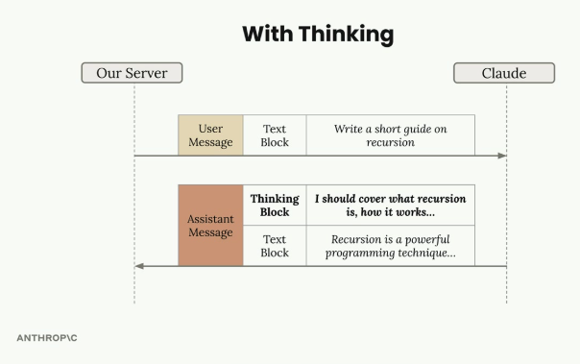
With extended thinking enabled, the assistant message contains a Thinking Block followed by the final Text Block.

Benefits
- Better reasoning — improved capability on complex tasks.
- Higher accuracy — on difficult problems where standard prompting falls short.
- Transparency — visibility into Claude's thought process.

Trade-offs
- Higher cost — thinking tokens are billed.
- Increased latency — thinking takes time before the final answer arrives.
- More complex response handling — code must handle the extra block type.

When to Use Extended Thinking
The decision is driven by evaluation results, not intuition: run prompts without thinking first, and if accuracy isn't meeting requirements after the prompt has already been optimized, then consider enabling extended thinking. It's a tool for when standard prompting isn't quite getting you there — not a default to switch on for every request.

The Signature: Response Security
Extended thinking responses include a signature field — a cryptographic token tied to the exact thinking text Claude generated. It verifies that the thinking content wasn't modified before being sent back to the API, preventing a developer from tampering with Claude's reasoning process in a way that could steer the model in unsafe directions.
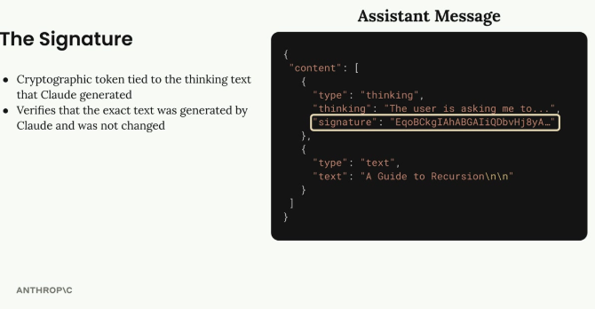
The signature field inside the thinking block is a cryptographic token tied to the exact reasoning text — it must be passed back unchanged.

Redacted Thinking
Sometimes, instead of readable reasoning text, the API returns a redacted_thinking block. This happens when Claude's internal reasoning gets flagged by safety systems. The block still contains the actual thinking, but encrypted, so the full message can be passed back to Claude in later turns without losing context. For testing, a special trigger string can be sent as the prompt to force a redacted thinking block, so an application's handling of this case can be verified without waiting for a real flag.

Implementation
Enabling extended thinking takes two new parameters on the chat function: a thinking flag and a thinking_budget (the max tokens Claude may use for reasoning, minimum 1024). The max_tokens parameter must be set higher than the thinking budget.
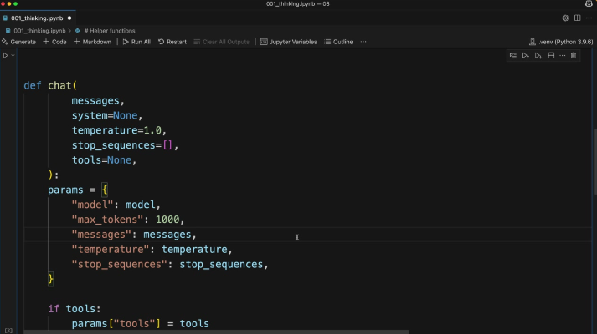
The chat() helper function that gets extended with thinking and thinking_budget parameters.
def chat(
messages,
system=None,
temperature=1.0,
stop_sequences=[],
tools=None,
thinking=False,
thinking_budget=1024
):
The thinking configuration is only added to the request parameters when thinking is turned on:
if thinking:
params["thinking"] = {
"type": "enabled",
"budget": thinking_budget
}
Calling it is then a matter of passing the flag:
chat(messages, thinking=True)

Practice Questions — Lesson 1
Choose the single best answer for each question (A–E).
1. What is extended thinking best described as?
A) A way to fine-tune Claude on custom data
B) A feature that gives Claude time to reason through a problem before the final answer, shown as a separate thinking block
C) A tool that lets Claude browse the web
D) A caching mechanism for repeated prompts
E) A way to reduce the number of tokens in a response
2. Which of the following is NOT listed as a benefit of extended thinking?
A) Better reasoning on complex tasks
B) Increased accuracy on difficult problems
C) Transparency into Claude's thought process
D) Lower latency on every request
E) Often results in higher quality responses
3. According to the lesson, when should a developer consider enabling extended thinking?
A) On every single API call, by default
B) Only for creative writing tasks
C) After running prompt evaluations without thinking and finding accuracy still isn't sufficient once the prompt is already optimized
D) Only when the user explicitly types "think" in the prompt
E) Never — it should be avoided in production
4. What does the signature field in a thinking block verify?
A) That the user's API key is valid
B) That the model used was Claude 4
C) That the thinking text is exactly what Claude generated and was not modified
D) That the response fits within max_tokens
E) That the thinking block was translated correctly
5. What triggers a redacted_thinking block instead of a normal thinking block?
A) The thinking_budget is set too low
B) The user asks a factual question
C) Claude's internal reasoning gets flagged by safety systems
D) The max_tokens parameter is missing
E) The request does not include any tools
6. In the redacted_thinking case, what happens to the underlying reasoning content?
A) It is permanently deleted and cannot be reused
B) It is kept in encrypted form so it can be passed back to Claude without losing context
C) It is shown to the developer but hidden from the end user
D) It is converted into a normal text block automatically
E) It is replaced with a generic placeholder message with no relation to the original reasoning

Lesson 2 — Image Support

Core idea
Claude's vision capabilities let you include images in messages and ask Claude to analyze them: describe what's in an image, compare multiple images, count objects, or perform more complex visual analysis.

Limits to Keep in Mind
- Up to 100 images across all messages in a single request.
- Max size of 5MB per image.
- Single image: max height/width of 8000px.
- Multiple images: max height/width of 2000px.
- Encoding — images can be sent as base64 or as a URL to the image.
- Token cost — each image counts as tokens = (width px × height px) / 750.

Sending an Image
An image block goes in the user message alongside a text block. The image is read from disk, base64-encoded, and passed with its media type; the text block carries the question about the image.
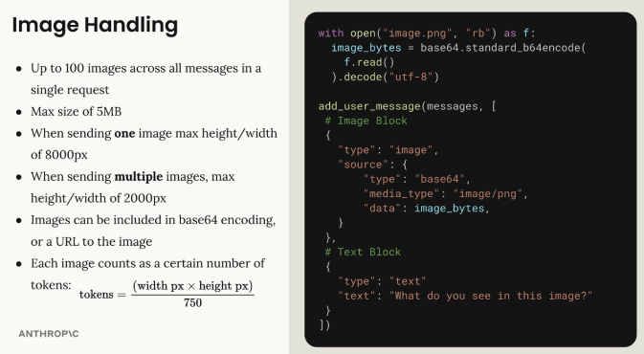
An image block (base64-encoded PNG) plus a text block, both inside the same user message.
with open("image.png", "rb") as f:
image_bytes = base64.standard_b64encode(
f.read()
).decode("utf-8")

add_user_message(messages, [
# Image Block
{
"type": "image",
"source": {
"type": "base64",
"media_type": "image/png",
"data": image_bytes,
}
},
# Text Block
{
"type": "text",
"text": "What do you see in this image?"
}
])

Message Flow
The conversation works just like text-only interactions: the server sends a user message with both an image block and a text block, and Claude responds with a text block containing its analysis.
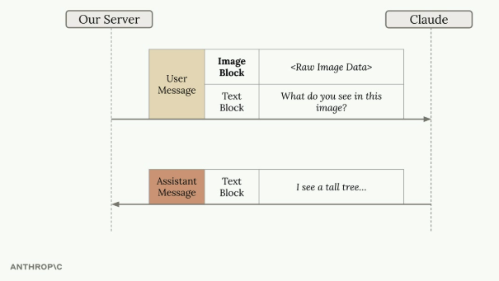
User message carries an Image Block plus a Text Block; Claude replies with a Text Block describing what it sees.

Prompting Techniques for Images
The same prompt engineering techniques that work for text apply to images. A simple question often leads to poor results — asking "How many marbles are in this image?" can return an incorrect count.
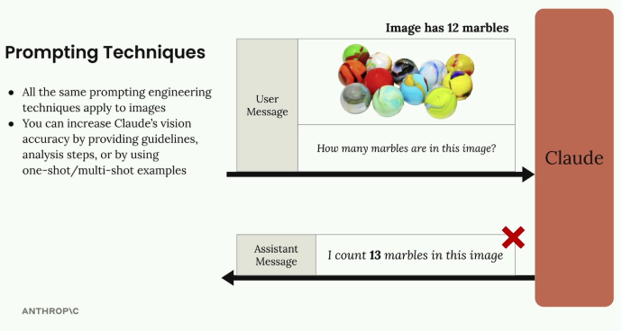
A simple question ("How many marbles?") on an image of 12 marbles returns the wrong count: 13.
Accuracy improves by providing detailed guidelines and analysis steps, using one-shot or multi-shot examples, and breaking complex tasks into smaller steps.

Step-by-Step Analysis
Instead of a simple question, give Claude a methodology to follow — identify and number each item one at a time, then verify with a second counting method (e.g. row by row from a fixed starting corner). Asking for the exact, verified number this way corrects the earlier miscount.
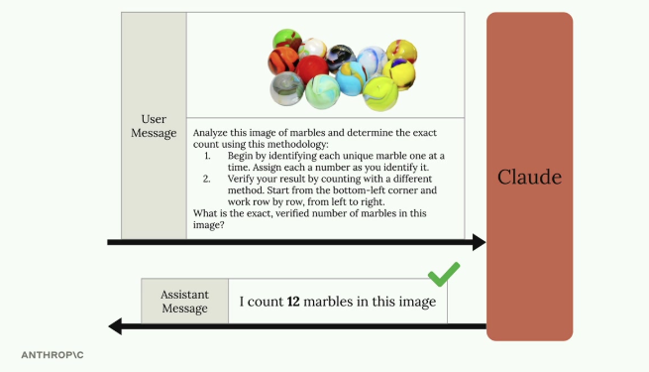
A structured, two-step counting methodology gets the correct count: 12 marbles.

One-Shot Examples
Accuracy can also improve by providing an example within the message: include a reference image with a known, stated count, then ask about the target image. This gives Claude a concrete reference point for the type of analysis expected before it answers the real question.
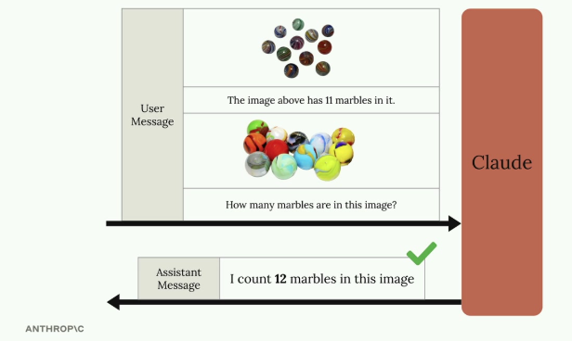
A reference image labeled with its known count (11 marbles) precedes the target image, helping Claude correctly count 12 marbles in the second image.

Real-World Example: Fire Risk Assessment
A practical application: automating fire risk assessments for home insurance. Instead of sending inspectors to every property, insurers can analyze high-resolution satellite imagery with Claude, identifying dense tree cover near the residence, difficult access for emergency services, and branches overhanging the structure.
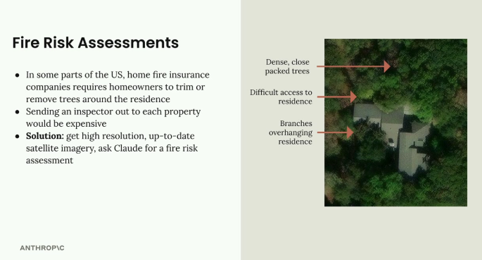
Satellite imagery annotated with fire-risk factors: dense packed trees, difficult residence access, and overhanging branches.
Rather than a vague prompt like "provide a fire risk score," a well-structured prompt breaks the analysis into explicit steps: locate the residence, analyze tree overhang and estimate the percentage of roof covered, assess wildfire vulnerability factors, evaluate the property's defensible space, and only then assign a Fire Risk Rating from 1 (Low) to 4 (Severe) — one summary sentence per step, with the numerical rating as the final answer. This systematic structure produces far more accurate and useful assessments than a simple request.

Practice Questions — Lesson 2
Choose the single best answer for each question (A–E).
1. What is the maximum number of images allowed across all messages in a single request?
A) 10
B) 20
C) 50
D) 100
E) There is no limit
2. When sending multiple images in a single request, what is the max height/width per image?
A) 2000px
B) 5000px
C) 8000px
D) 10000px
E) There is no size limit for multiple images
3. How is the token cost of an image calculated?
A) A flat 1000 tokens per image regardless of size
B) (width px × height px) / 750
C) (width px + height px) / 2
D) Based on file size in MB only
E) Images do not consume tokens
4. Why did the simple prompt "How many marbles are in this image?" return an incorrect count?
A) Because the image exceeded the 5MB size limit
B) Because Claude cannot process images with more than one color
C) Because a simple, unstructured prompt often leads to poor results on precise visual tasks
D) Because the image was sent as a URL instead of base64
E) Because counting tasks are not supported by the vision API
5. According to the lesson, which techniques improve Claude's accuracy on image analysis tasks?
A) Sending only the image with no text block at all
B) Detailed guidelines and analysis steps, one-shot/multi-shot examples, and breaking tasks into smaller steps
C) Always resizing images to exactly 8000px
D) Repeating the same question multiple times in the same message
E) Removing all context and asking the shortest possible question
6. In the fire risk assessment example, what is the final output of the structured prompt?
A) A raw list of every tree detected in the image
B) A one-sentence summary per analysis step, ending in a numerical Fire Risk Rating from 1 to 4
C) A base64-encoded copy of the satellite image
D) A yes/no answer on whether to send an inspector
E) The exact GPS coordinates of the residence

Lesson 3 — PDF Support

Core idea
Claude can read and analyze PDF files directly, making it a powerful tool for document processing. This works similarly to image processing, but with a few key differences in how the code is structured.

Setting Up PDF Processing
Processing a PDF uses nearly identical code to processing an image — the file is read from disk and base64-encoded, then sent as a block alongside a text block asking a question about it.
with open("earth.pdf", "rb") as f:
file_bytes = base64.standard_b64encode(f.read()).decode("utf-8")

messages = []

add_user_message(
messages,
[
{
"type": "document",
"source": {
"type": "base64",
"media_type": "application/pdf",
"data": file_bytes,
},
},
{"type": "text", "text": "Summarize the document in one sentence"},
],
)

chat(messages)

Key Changes from Image Processing
- File extension — from .png to .pdf.
- Variable name — from image_bytes to file_bytes, for clarity.
- Block type — "document" instead of "image".
- Media type — "application/pdf" instead of "image/png".

What Claude Can Extract from PDFs
Claude's PDF processing goes beyond simple text extraction. It can analyze and understand text content throughout the document, images and charts embedded in the PDF, tables and their data relationships, and the document's overall structure and formatting — making it a one-stop solution for summaries, data analysis, or specific content extraction from PDF files.
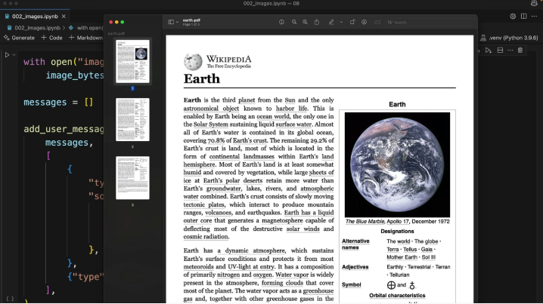
Claude reading a Wikipedia article about Earth saved as a PDF, using the same document-block code shown above.

Practice Questions — Lesson 3
Choose the single best answer for each question (A–E).
1. How does sending a PDF to Claude compare structurally to sending an image?
A) It requires a completely different API endpoint
B) It uses nearly identical code, with a few key differences in type and media_type
C) PDFs must be converted to images before sending
D) PDFs cannot be sent in the same message as text
E) PDFs require a separate authentication method
2. What value should the "type" field have for a PDF block, instead of "image"?
A) "file"
B) "pdf"
C) "document"
D) "attachment"
E) "binary"
3. What media_type should be used when sending a PDF?
A) "image/pdf"
B) "file/pdf"
C) "application/pdf"
D) "document/pdf"
E) "text/pdf"
4. According to the lesson, what is Claude able to extract from a PDF beyond plain text?
A) Nothing — only raw text can be extracted
B) Images, charts, tables, and overall document structure
C) Only the page count and file metadata
D) Only the document's creation date
E) Only hyperlinks present in the document
5. Why was the variable renamed from image_bytes to file_bytes in the PDF example?
A) Because image_bytes is a reserved keyword in Python
B) Because the API rejects that variable name for PDFs
C) Purely for clarity, since the content is no longer an image
D) Because file_bytes triggers a different encoding automatically
E) Because PDFs must be stored as a list of bytes objects

Lesson 4 — Citations

Core idea
Citations let Claude reference specific parts of the source documents you provide and show users exactly where each piece of information came from — turning Claude from a "black box" answer generator into a transparent research assistant that shows its work.

Why Citations Matter
Without citations, a user asking about a document has no way to verify Claude's answer or confirm it's actually grounded in the source material provided, rather than in Claude's training data. Citations create a clear, checkable trail from Claude's response back to the exact source text.

Enabling Citations
Citations are enabled by adding two fields to the document block: a title (a readable name for the document) and citations: {"enabled": True} (which tells Claude to track where it finds information).
{
"type": "document",
"source": {
"type": "base64",
"media_type": "application/pdf",
"data": file_bytes,
},
"title": "earth.pdf",
"citations": { "enabled": True }
}

Citation Structure
With citations enabled, the response becomes structured data: each claim carries a citation with several fields — cited_text (the exact source text supporting the statement), document_index (which document, when multiple are provided), document_title, and start_page_number / end_page_number marking where the cited text begins and ends.
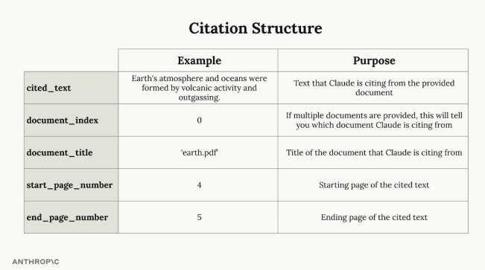
The five citation fields, with an example drawn from the earth.pdf document: cited_text, document_index, document_title, start_page_number, and end_page_number.

Building User Interfaces with Citations
The real value of citations shows up in the UI built around them — for example, letting users hover over a citation marker to see exactly where the information came from. This lets users see that answers are grounded in real source material, verify claims against the original document, and understand the surrounding context of each cited fact.

Citations with Plain Text
Citations aren't limited to PDFs — they also work with plain text sources, using the same title and citations: {"enabled": True} fields, just with a text-based source block instead of base64. With plain text, citations report character positions instead of page numbers, pinpointing exactly where in the text Claude found each piece of information.
{
"type": "document",
"source": {
"type": "text",
"media_type": "text/plain",
"data": article_text,
},
"title": "earth_article",
"citations": { "enabled": True }
}

When to Use Citations
- Verification — users need to check information for accuracy.
- Authoritative documents — sources that users should be able to reference directly.
- Transparency — being clear about where information comes from is critical for the application.
- Deeper context — users might want to explore the source material surrounding a specific fact.

Practice Questions — Lesson 4
Choose the single best answer for each question (A–E).
1. What problem do citations solve that a plain, non-cited response does not?
A) They make Claude's responses shorter
B) They let users verify that an answer is actually grounded in the provided source document
C) They remove the need for a text block in the response
D) They reduce the number of tokens used
E) They allow Claude to answer without any document at all
2. Which two fields need to be added to a document block to enable citations?
A) "citations": true and "page": 1
B) "source" and "data"
C) "title" and "citations": {"enabled": True}
D) "media_type" and "encoding"
E) "index" and "reference"
3. In the citation structure, what does document_index indicate?
A) The page number where the citation starts
B) Which document Claude is citing from, when multiple documents are provided
C) The total number of documents sent in the request
D) The character position of the cited text
E) The order in which citations appear in Claude's answer
4. When using citations with a plain text source instead of a PDF, what replaces the page number fields?
A) Paragraph numbers
B) Character positions within the text
C) Line numbers only
D) Nothing — plain text sources don't support citations
E) Word counts
5. According to the lesson, when are citations particularly valuable?
A) Only when working with images, never with text documents
B) When users need to verify accuracy, work with authoritative sources, or need transparency and deeper context
C) Only in applications with no user interface
D) Only when max_tokens is set to its lowest value
E) Only when the document is shorter than one page

Lesson 5 — Prompt Caching

Core idea
Prompt caching speeds up Claude's responses and reduces cost by reusing computational work from previous requests, instead of throwing that work away and redoing it every time similar content is sent again.

How Claude Normally Processes a Request
Without caching, sending a message doesn't jump straight to generating a response. Claude first does a large amount of preprocessing on the input: tokenizing the prompt, creating embeddings for each token, and adding context based on surrounding text — only then does it generate the output text.
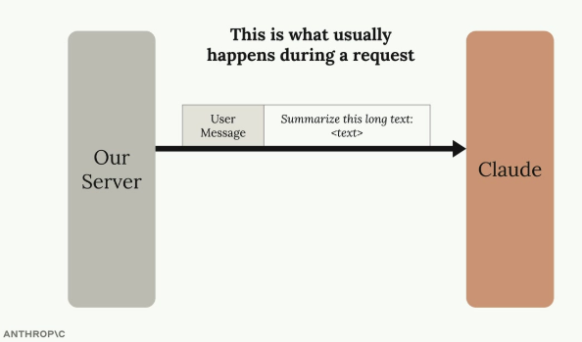
What usually happens during a request: the server sends the user message and Claude processes it from scratch.
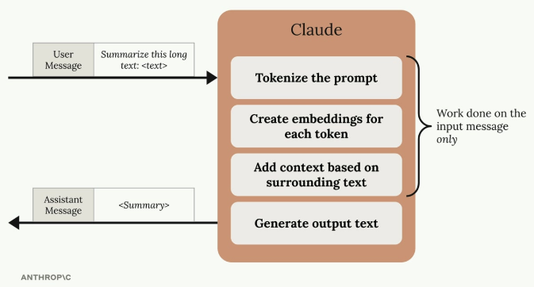
Work done on the input message only: tokenize the prompt, create embeddings, add context, then generate output text.

The Problem with Discarding Work
After the response is sent, all of that preprocessing work — tokenization, embeddings, context analysis — gets thrown away by default.
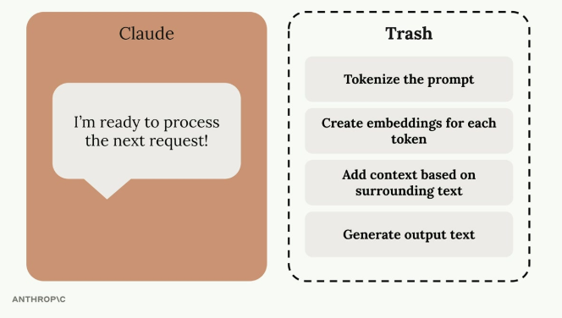
Without caching, all preprocessing work (tokenizing, embeddings, context) is discarded right after the response is sent.
This becomes wasteful in follow-up requests that repeat the same content — for example, asking Claude to refine a summary of the same long text. Claude ends up repeating identical preprocessing work on content it just analyzed moments earlier.
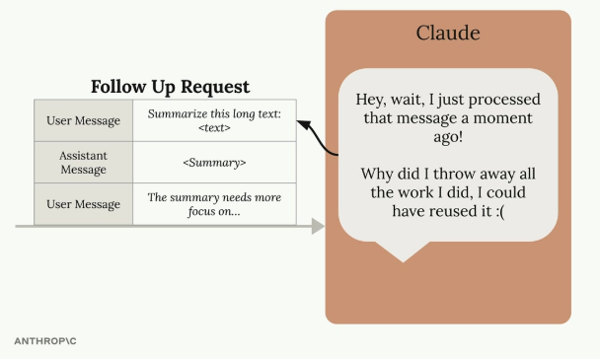
A follow-up request reusing the same long text forces Claude to redo work it had already discarded from the initial request.

How Prompt Caching Solves This
Prompt caching changes this by saving the preprocessing results instead of discarding them. On the initial request, Claude still does the usual preprocessing, but writes the results to a cache instead of throwing them away.
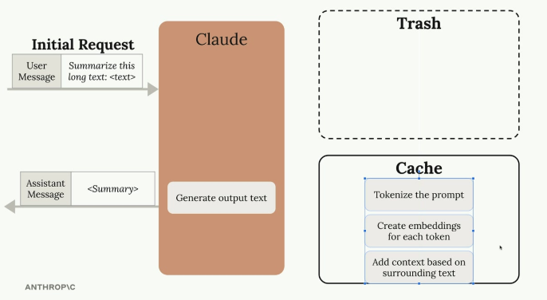
The initial request's preprocessing work (tokenizing, embeddings, context) is written to the cache instead of the trash; only output generation still runs per request.
The cache works like a lookup table: "if I ever see this message again, I'll reuse this work I already did" — instead of redoing tokenization, embeddings, and context analysis from scratch.
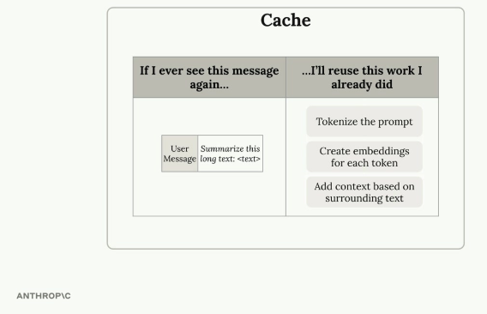
The cache maps a previously seen message to the preprocessing work already completed for it, ready to be reused.

Key Benefits and Limitations
- Faster responses — requests using cached content execute more quickly.
- Lower costs — cached portions of a request cost less.
- Automatic optimization — the initial request writes to the cache, follow-up requests read from it.
- Cache duration — cached content only lives for one hour.
- Limited use cases — only beneficial when the same content is repeatedly sent.
- High frequency requirement — most effective when the same content appears extremely often across requests.

When to Use Prompt Caching
Prompt caching works best in scenarios like document analysis workflows — asking multiple questions about the same large document — or iterative editing tasks, where the base content stays constant while specific aspects get refined across several requests.

Practice Questions — Lesson 5
Choose the single best answer for each question (A–E).
1. What happens to Claude's preprocessing work (tokenization, embeddings, context) after a normal request without caching?
A) It is stored permanently for future use
B) It is discarded after the response is sent
C) It is sent back to the user along with the response
D) It is compressed and reused automatically forever
E) It is used to retrain the model
2. What does prompt caching change about this default behavior?
A) It skips the preprocessing step entirely, even on the first request
B) It saves the preprocessing results in a cache instead of discarding them
C) It sends the preprocessing work to the user's own server
D) It removes the need for tokenization altogether
E) It only affects the final output generation step, not preprocessing
3. How long does cached content live before it expires?
A) 5 minutes
B) 1 hour
C) 24 hours
D) 1 week
E) Indefinitely, until manually cleared
4. Which scenario benefits most from prompt caching?
A) Sending completely different, unrelated prompts each time
B) A single one-off request with no follow-ups
C) Asking multiple questions about the same large document
D) Requests that never repeat any content
E) Reducing the size of the model's context window
5. What are the two main benefits of prompt caching mentioned in the lesson?
A) Larger context windows and more tools
B) Faster responses and lower costs on cached content
C) Better accuracy and more creative outputs
D) Unlimited cache duration and free requests
E) Automatic translation and summarization

Lesson 6 — Rules of Prompt Caching

Core idea
Prompt caching stores the computational work done on messages so it can be reused in follow-up requests, making them faster and cheaper — but only when identical content is repeatedly sent. The initial request writes processing work to the cache; follow-up requests can read from it instead of reprocessing. The cache lives for one hour, so this only pays off when the same content repeats within that window.
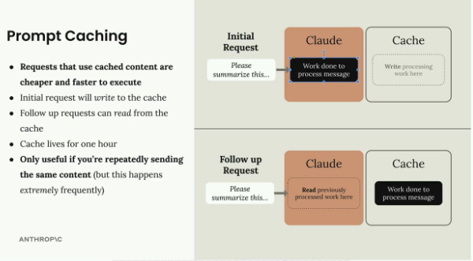
Recap: an initial request writes processing work to the cache; a follow-up request with identical content reads that work back instead of reprocessing it.

Cache Breakpoints
Caching is not automatic — a cache breakpoint must be manually added to a specific block. Work done for everything before (and including) the breakpoint gets cached; the cache is only reused on a follow-up request if the content up to and including the breakpoint is identical.
- Not automatic — work on messages is not cached by default.
- Manual breakpoint — must be added explicitly to a block.
- Scope — everything before and including the breakpoint gets cached.
- Exact match required — the cache is reused only if content up to the breakpoint is identical.
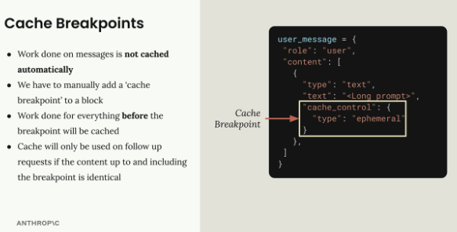
A cache breakpoint is added to a block via the "cache_control": {"type": "ephemeral"} field.

Shorthand vs. Longhand
The shorthand form for a text block (content as a plain string) has no place to attach a cache_control field. To add a breakpoint, the longhand form must be used instead — the expanded block structure with an explicit "type": "text" entry, so the cache_control field has somewhere to go.
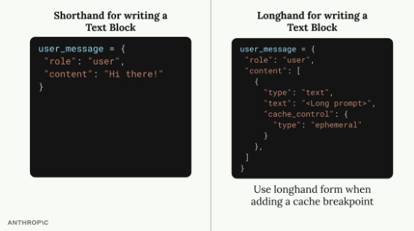
Shorthand text blocks can't carry cache_control; the longhand form is required whenever a breakpoint is added.
Even a small change, like adding the word "please", invalidates the cache and forces Claude to reprocess everything up to the breakpoint from scratch — the match must be exact.

Cross-Message Caching
A cache breakpoint isn't limited to a single message — it can span multiple messages and message types. Placing a breakpoint in a later message means all earlier messages (user, assistant, etc.) are included in the cached content, which is especially useful for caching an entire conversation's context up to a certain point.
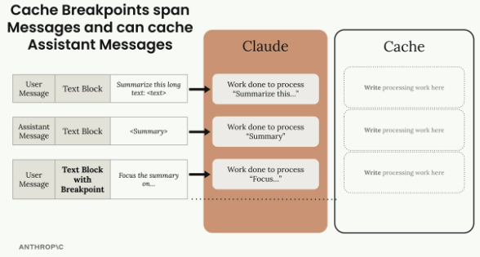
A breakpoint placed on a later user message caches the processing work for every message before it too, including prior assistant messages.
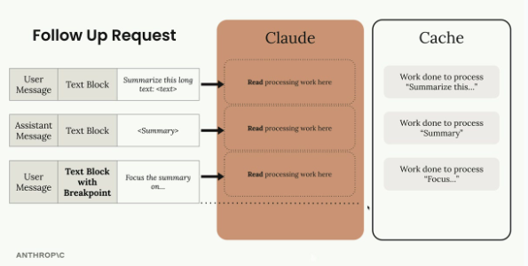
On a follow-up request with identical prior content, Claude reads the cached work for each message up to the breakpoint instead of reprocessing them.

System Prompts and Tools
Breakpoints aren't limited to text blocks — they can also be added to system prompts, tool definitions, image blocks, and tool use / tool result blocks. System prompts and tool definitions are excellent caching candidates since they rarely change between requests, which is often where prompt caching pays off the most.
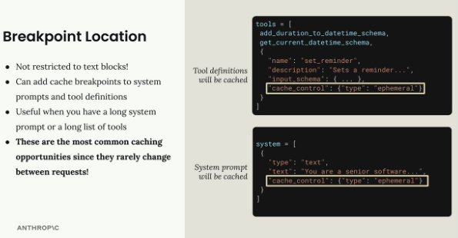
Cache breakpoints added to a tool definition and to a system prompt — both rarely change between requests, making them prime caching targets.

Cache Ordering
Claude processes request components in a fixed order behind the scenes: tools first, then the system prompt, then messages. Up to four cache breakpoints can be used in a single request — for example, caching the tools list and separately caching part of the conversation history — giving flexibility over what gets cached as different parts of a request change.
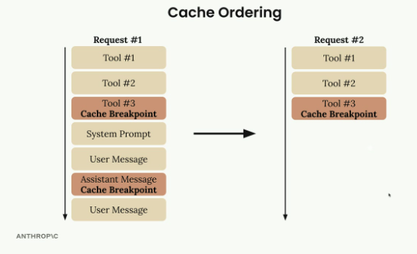
Processing order (tools → system prompt → messages) with breakpoints placed after Tool #3 and after an assistant message, reused identically across requests.

Minimum Content Length
There's a minimum size to be eligible for caching: the content being cached must total at least 1024 tokens — summed across all the messages and blocks up to the breakpoint, not any individual block alone. A short message like "Hi there!" won't meet this threshold on its own, but a genuinely long prompt, or that same short content repeated many times, will.

Practice Questions — Lesson 6
Choose the single best answer for each question (A–E).
1. Is prompt caching applied automatically to every message sent to Claude?
A) Yes, all messages are cached by default
B) No, a cache breakpoint must be manually added to a block
C) Yes, but only for system prompts
D) No, caching must be enabled in the Anthropic console first
E) Yes, but only for the first message in a conversation
2. Why is the longhand form required when adding a cache breakpoint to a text block?
A) The shorthand form is deprecated and no longer works
B) The shorthand form (a plain string) has no place to attach the cache_control field
C) Longhand form is required by the Anthropic terms of service
D) Longhand form uses fewer tokens
E) There is no real difference; either form works identically
3. What happens if the content up to a cache breakpoint is not exactly identical to a previous request (e.g., adding the word "please")?
A) Claude ignores the difference and uses the cache anyway
B) The cache is invalidated and Claude reprocesses everything up to the breakpoint
C) Claude returns an error and rejects the request
D) Only the changed word is reprocessed, the rest stays cached
E) The cache duration is automatically extended
4. Besides text blocks, where else can cache breakpoints be placed?
A) Only in the model parameter
B) System prompts, tool definitions, image blocks, and tool use/result blocks
C) Only in the temperature parameter
D) Nowhere else — text blocks are the only supported location
E) Only in stop_sequences
5. What is the minimum content length required for something to be eligible for caching?
A) 100 tokens
B) 500 tokens
C) 1024 tokens
D) 4096 tokens
E) There is no minimum
6. How many cache breakpoints can be used in a single request, and in what order are components processed?
A) Unlimited breakpoints; messages are processed before tools
B) Up to four breakpoints; tools are processed first, then system prompt, then messages
C) Exactly one breakpoint; system prompt is processed first
D) Up to four breakpoints; messages are processed first, then tools
E) Unlimited breakpoints; only the system prompt can be cached

Lesson 7 — Prompt Caching in Action

Core idea
This lesson implements prompt caching in code: the first request writes content to a cache that lives for one hour, and follow-up requests read from it instead of reprocessing. This pays off most for large system prompts (e.g. a ~6K token coding assistant prompt), complex tool schemas (~1.7K tokens for multiple tools), and repeated message content — anywhere the same content is sent identically and frequently.

Caching Tool Schemas
A cache breakpoint is added to the last tool in the list, not to the whole list at once. Copies of the tools list and the last tool are made before adding cache_control, so the original tool definitions aren't mutated.
if tools:
tools_clone = tools.copy()
last_tool = tools_clone[-1].copy()
last_tool["cache_control"] = {"type": "ephemeral"}
tools_clone[-1] = last_tool
params["tools"] = tools_clone
Directly modifying tools[-1]["cache_control"] would also work, but copying first avoids problems if the tools list gets reordered later.

Caching the System Prompt
System prompts must be restructured from a plain string into a list containing a text block, so there's a place to attach cache_control — the same shorthand-vs-longhand distinction seen with text blocks in messages.
if system:
params["system"] = [
{
"type": "text",
"text": system,
"cache_control": {"type": "ephemeral"}
}
]

Understanding Cache Behavior
The API response reports cache activity through usage fields: on the first request, cache_creation_input_tokens shows the tokens written to the cache; on follow-up requests with identical cached content, cache_read_input_tokens shows the tokens read back instead of reprocessed. If the cached content changes, new cache_creation_input_tokens appear again instead of a cache read.
- First request: cache_creation_input_tokens=1772 — Claude writes to the cache.
- Follow-up request: cache_read_input_tokens=1772 — Claude reads from the cache.
- Changed content: new cache_creation_input_tokens appear instead of a read.
The cache is extremely sensitive — changing even a single character in the tools or system prompt invalidates the entire cache for that component.

Cache Ordering and Breakpoints
Multiple cache breakpoints can be set in one request, and the order in which components are cached matters: tools first, then system prompt, then messages. If the system prompt changes but the tools stay the same, the response shows a partial cache read for the tools plus a fresh cache write for the new system prompt — this granular caching means only the parts that actually changed get reprocessed and paid for.

Practical Considerations
Prompt caching pays off most with consistent tool schemas across requests, stable system prompts, and applications that make multiple requests sharing similar context. Since the cache only lasts one hour, it's designed for applications with relatively frequent API usage, not for long-term storage.

Practice Questions — Lesson 7
Choose the single best answer for each question (A–E).
1. Where is the cache breakpoint added when caching a list of tool schemas?
A) On the first tool in the list
B) On every tool in the list individually
C) On the last tool in the list
D) On the tools parameter as a whole string
E) Tools cannot be cached, only messages
2. Why does the tool-caching code copy the tools list and the last tool before adding cache_control?
A) Copying is required by the API and requests fail otherwise
B) It avoids mutating the original tool definitions and prevents issues if tools get reordered later
C) It reduces the number of tokens sent to Claude
D) It automatically increases the cache duration beyond one hour
E) It converts the tools into a system prompt
3. How must a system prompt be restructured to support caching?
A) It must be converted into a list of tool definitions
B) It must be split into multiple separate system prompts
C) It must become a list containing a text block with a cache_control field
D) It must be base64-encoded
E) No restructuring is needed — plain strings support caching directly
4. What does cache_read_input_tokens in a response indicate?
A) The number of tokens that were newly written to the cache
B) The number of tokens read back from the cache instead of being reprocessed
C) The total number of tokens in the entire conversation
D) The number of tokens that failed to cache
E) The maximum tokens allowed in the cache
5. If the tools stay identical between two requests but the system prompt changes, what does the response show?
A) A full cache read for everything, including the new system prompt
B) A full cache miss for both tools and system prompt
C) A partial cache read for the tools plus a fresh cache write for the new system prompt
D) An error, since changing the system prompt is not allowed with caching enabled
E) The cache is disabled automatically for the rest of the session

Lesson 8 — Code Execution and Files API

Core idea
The Files API and the code execution tool are two separate Anthropic API features that work exceptionally well together, opening up ways to delegate complex, computational tasks to Claude while keeping control over inputs and outputs.

Files API
Instead of encoding images or PDFs directly as base64 data in every message, the Files API lets you upload a file ahead of time and reference it later by ID: upload the file once via a separate API call, receive a file metadata object with a unique file ID, then reference that ID in future messages instead of including the raw file data. This is especially useful when referencing the same file multiple times, or working with larger files that would be cumbersome to inline in every request.
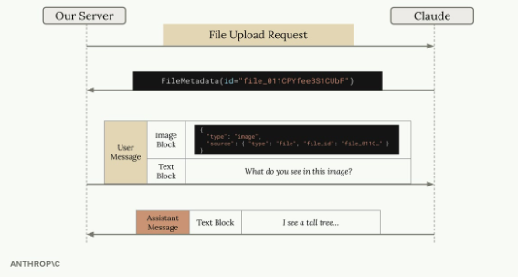
A file is uploaded once to get a FileMetadata object with a file ID; later messages reference that file_id inside an image block instead of raw base64 data.

Code Execution Tool
Code execution is a server-based tool — no implementation needs to be provided. A predefined tool schema is included in the request, and Claude can optionally execute Python code in an isolated Docker container.
- Isolated — runs in a Docker container.
- No network access — the container can't make external API calls.
- Multiple executions — Claude can run code more than once within a single conversation.
- Interpreted results — execution output is captured and interpreted by Claude for the final response.
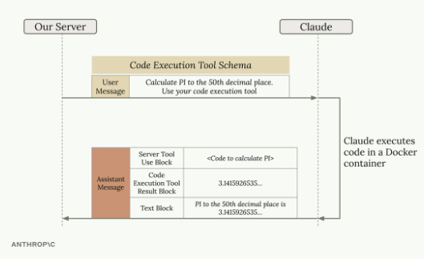
Claude executes code in a Docker container to compute a result (here, PI to 50 decimal places), then reports it in a final text block.

Combining Files API and Code Execution
Since the Docker container has no network access, the Files API becomes the primary way to get data in and out of the execution environment. Typical workflow: upload a data file (e.g. a CSV) via the Files API, include a container_upload block with the file ID in the message, ask Claude to analyze the data, Claude writes and executes code against the file, and Claude can generate outputs (like plots) available for download.
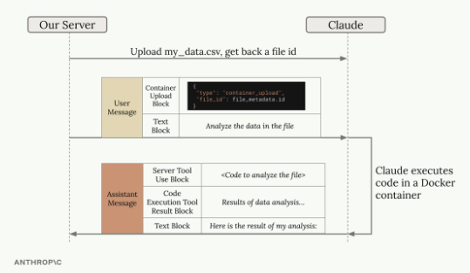
A CSV is uploaded to get a file ID, referenced via a container_upload block; Claude executes code against it inside the container and reports the analysis results.

Practical Example
Uploading a streaming service CSV (subscription tier, viewing habits, churn) and asking for a churn-driver analysis with a plot:
file_metadata = upload('streaming.csv')
messages = []
add_user_message(
messages,
[
{
"type": "text",
"text": """Run a detailed analysis to determine major drivers of churn.
Your final output should include at least one detailed plot summarizing your findings."""
},
{"type": "container_upload", "file_id": file_metadata.id},
],
)

chat(
messages,
tools=[{"type": "code_execution_20250522", "name": "code_execution"}]
)

Understanding the Response
A code-execution response can contain several block types: text blocks (Claude's analysis and explanations), server tool use blocks (the actual code Claude decided to run), and code execution tool result blocks (the output of running that code). Claude may execute code multiple times within a single response, iteratively building up its analysis — each cycle includes the code and its results.

Downloading Generated Files
Claude can generate files — like plots or reports — and make them available for download. A generated visualization gets stored in the container; blocks with type: "code_execution_output" in the response contain the file ID for that generated content, which can then be retrieved via the Files API.
download_file("file_id_from_response")

Beyond Data Analysis
- Image processing and manipulation.
- Document parsing and transformation.
- Mathematical computations and modeling.
- Report generation with custom formatting.
The key idea is delegating complex, computational tasks to Claude while keeping control over inputs and outputs through the Files API — turning Claude into a coding assistant that can actually execute and iterate on solutions, not just describe them.

Practice Questions — Lesson 8
Choose the single best answer for each question (A–E).
1. What does the Files API let you do that inlining base64 data does not?
A) Run code without the code execution tool
B) Upload a file once and reference it later by file ID across multiple messages
C) Bypass the need for a text block entirely
D) Automatically translate the file contents
E) Skip the need for an API key
2. What kind of tool is the code execution tool, in terms of implementation?
A) A client-side tool the developer must implement themselves
B) A server-based tool with a predefined schema — no implementation needs to be provided
C) A tool that only works with the Files API and nothing else
D) A deprecated feature no longer supported
E) A tool that requires a separate Docker installation on the developer's machine
3. Why does the Files API become the primary way to move data in and out of the code execution container?
A) Because the container has no network access and can't make external API calls
B) Because base64 encoding is not supported inside containers
C) Because the container has no disk storage
D) Because code execution only accepts CSV files
E) Because the Files API is required by the Anthropic terms of service
4. Which block type is used to reference an uploaded file when asking Claude to analyze it inside the code execution container?
A) "type": "image"
B) "type": "document"
C) "type": "container_upload"
D) "type": "file_reference"
E) "type": "code_execution_input"
5. How can a file generated by Claude during code execution (like a plot) be retrieved?
A) It's automatically emailed to the developer
B) By looking for a code_execution_output block containing a file ID, then downloading it via the Files API
C) It's returned as raw base64 directly inside the text block
D) Generated files cannot be retrieved, only described
E) By re-running the exact same request with a different model

